Ideation Phase
Brainstorm & Idea Prioritization

Date | 19-02-2026
Team ID | LTVIP2026TMIDS66350
Project Name | Calculating family expenses
Maximum Marks | 4 Marks

Brainstorm & Idea Prioritization :
Brainstorming for a family expense calculation system should focus on improving financial awareness, ease of tracking, automation, and decision-making for households. High-impact foundational ideas include daily expense entry, automatic total calculation, expense categorization, budget setting, real-time tracking, and report generation. More advanced features may include alerts for overspending, analytics dashboards, predictive budgeting, multi-user support for family members, and mobile integration.
When prioritizing, an impact-versus-effort approach is used. High-impact and low-effort features such as expense entry forms and automatic calculations should be implemented first. High-impact but complex features like predictive analytics or AI-based recommendations can be planned for later stages. Low-impact and high-effort features should be deprioritized.
The ideal implementation follows a phased approach — starting with basic expense recording and calculation, then optimizing with reporting and budget features, and finally adding advanced intelligence and integrations. This ensures the system is practical, user-friendly, and scalable for families of different sizes.
Step-1: Team Gathering, Collaboration and Select the Problem Statement
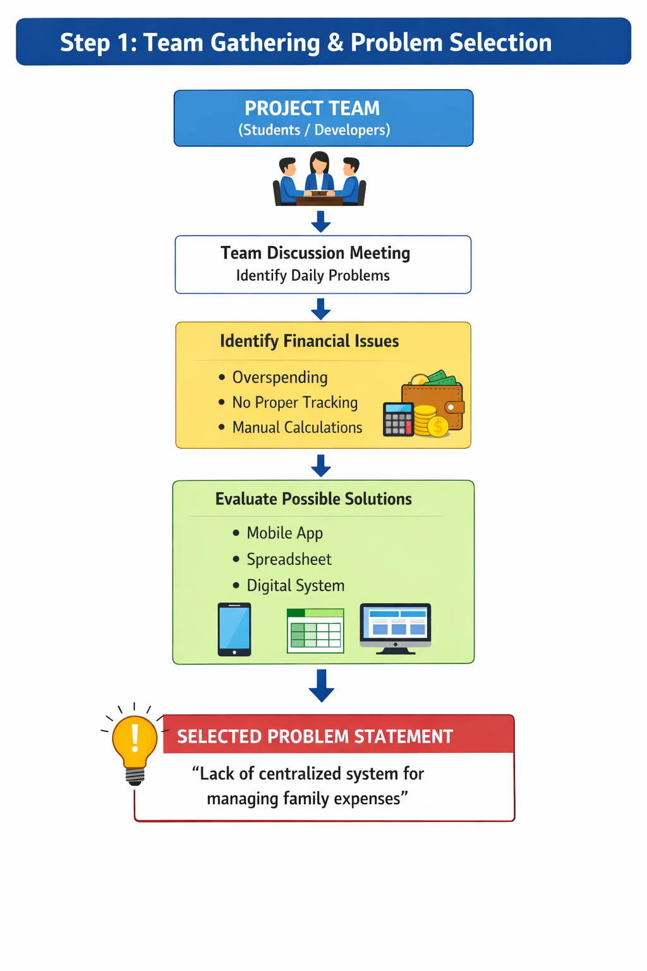

Step-2: Brainstorm, Idea Listing and Grouping
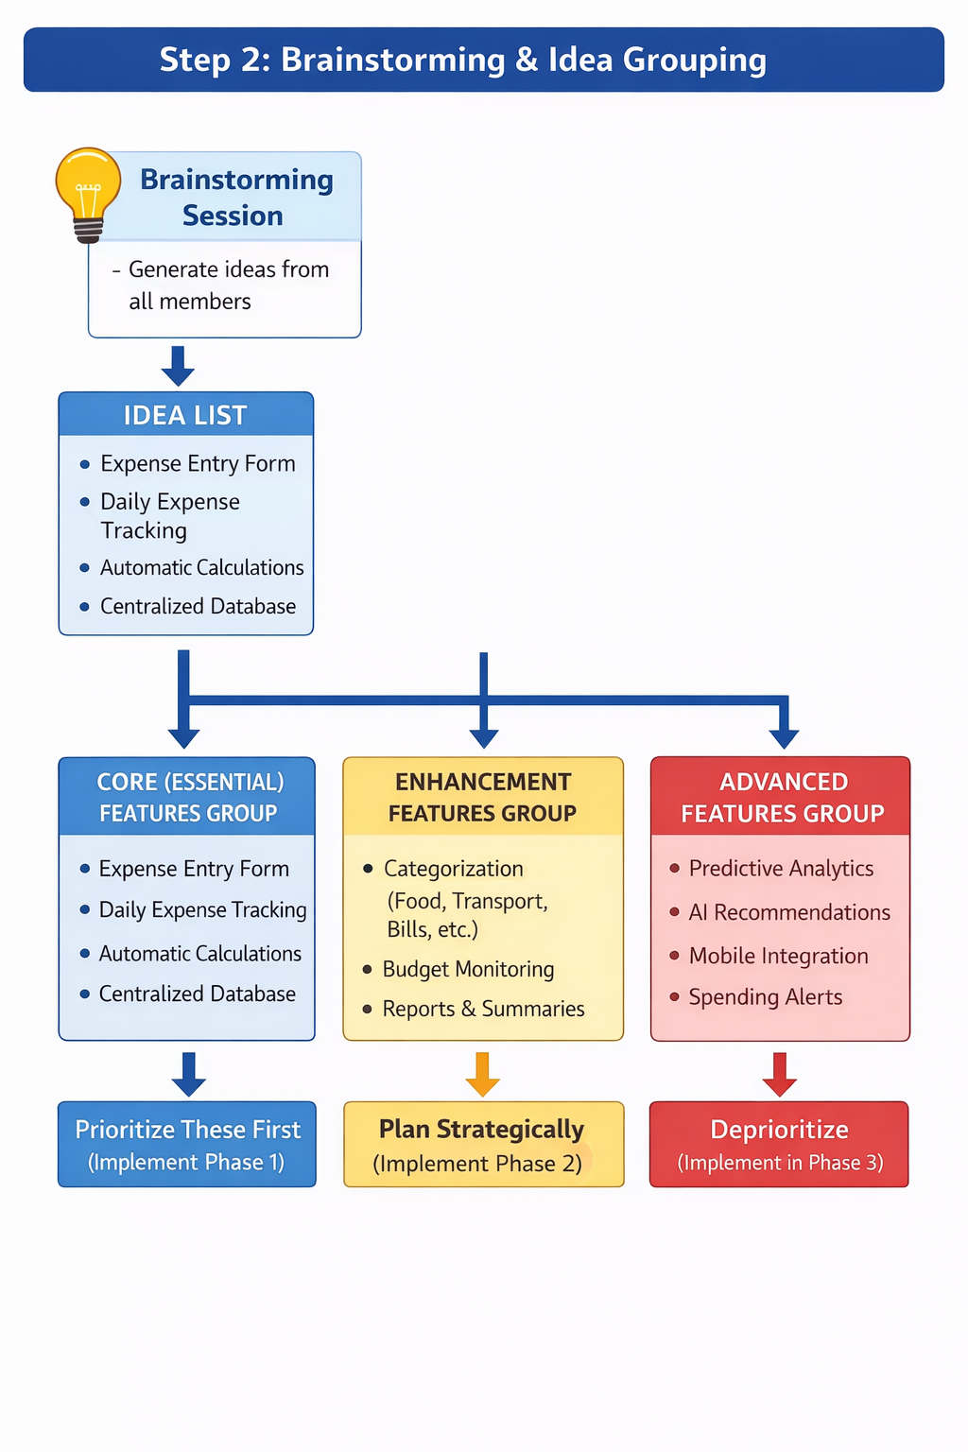

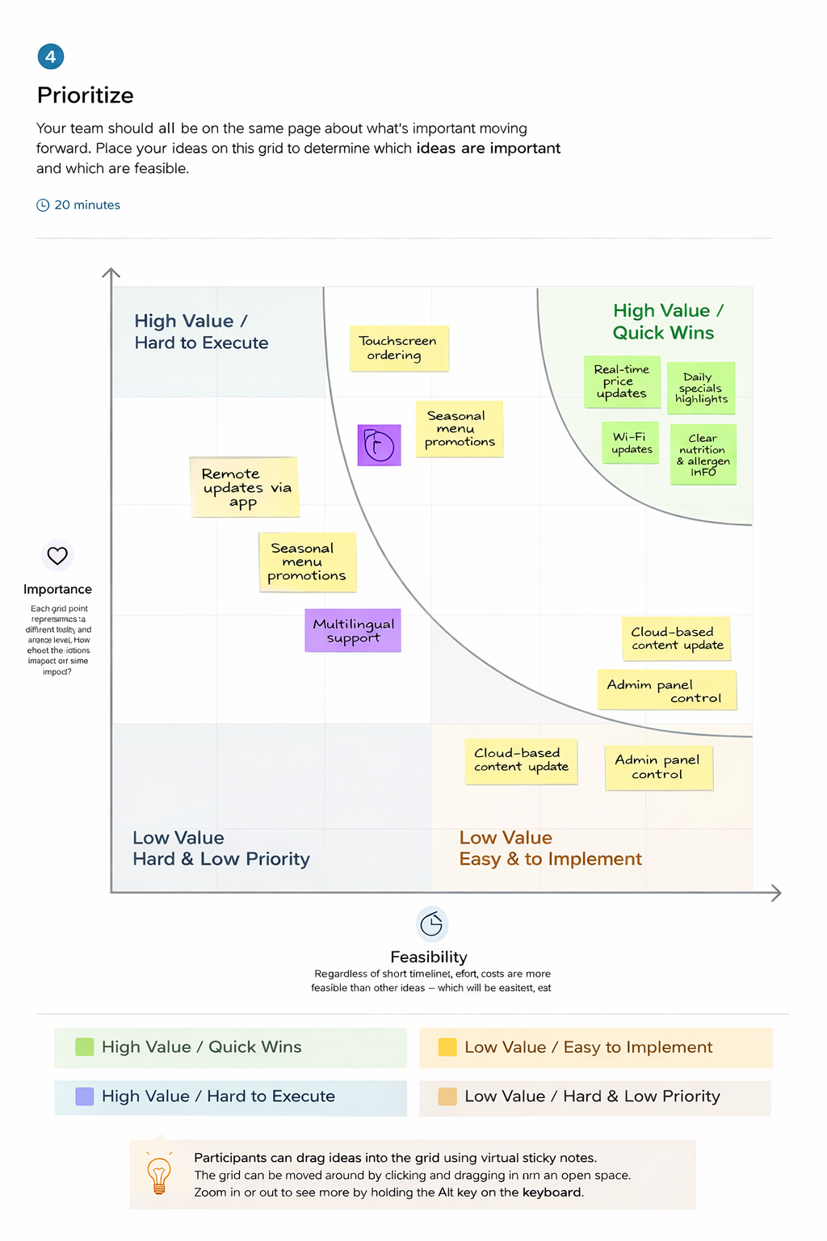
Step-3: Idea Prioritization:

